Field Visit Report (Barmer & Alwar)

Date : From January 29 to Feb 03, 2017
Projects : Soochna Seva, SoochnaPreneur & Oracle CIRC
Location : Barmer & Alwar of Rajasthan
Monitored by : Vahid & Maroof
Last visit : December 2016 by Kunwar
Report created by : Vahid
Focal person at the field : Shishir Purohit in Barmer & Pankaj Sharma in Alwar

Purpose of the visit
- To physically verify the activities of Soochna Seva Kendra, SoochnaPreneur Kendra & Oracle digital literacy center.
- To assist the team in opening the separate SoochnaPreneur Kendra in every block in order to reach out the last mile beneficiaries.
- To encourage the team for building up liaising with stakeholders both Govt. officials and elected members.
- To search out the possibilities of collaboration with the civil societies, elected members & block/district headquarter.
- To get familiar the team with required documentation both programmatic and admin/finance.
- To help the team in filling up complete online MIS along with photographs and evidence of each beneficiary of all three projects
- To assist the team in hiring of rest SoochnaPreneurs.
- To collect and resolve the grievances if any.
- To encourage the team for innovations.
Methodologies
- Checking of online MIS
- Verifying focused area wise schemes provided to the beneficiaries
- Capacity building of Soochna Seva team and SoochnaPreneurs
- Developing entrepreneurial skills
- Kick off paid activities in every SSK
- Prepare action plan

Field visit report-Barmer
It has been three years of DEF Soochna Seva Project in Barmer. Though, project has struggled a lot during the inception in providing the doorstep services to the last mile beneficiaries. This was because the team was fresh and fresh area for the organisation. However, a gradual significant improvement has given to the project a great success towards connecting with the people and winning their faith in Soochna Seva Kendra.
The performance of three SSKs (Barmer, Dhanau & Kalyanpur) is outstandingly well and rest 2 SSKs (Bayatu & Siwana) need much handholding support, in terms of monitoring, training, advocacy, outreach, partnerships, collaborations etc. Everywhere in all across 5 SSKs in Barmer, centre is being managed by either one person or two. The pace of disseminating information entitlement on public schemes in far behind these two centres. In addition, all 5 centres are struggling to provide digital literacy and digital services to the beneficiaries. This is because low density of the population and also associated other challenges i.e. poor transportation and having fewer resources in SSKs.
Below is the status of every Soochna Seva Kendra, SoochnaPreneur and Oracle centre.

Opening soon one SP centre
SP center in Punro ki Basti (1SP)
1 SP center in a village by 2 SP
Oracle Ramaniya (1 Fellow) Free accommodation

Dhanau Soochna Seva Kendra
The best and strong part of this SSK is its Block Coordinator, who is proactive and more energetic person. He has done a great work in project catchment area. Most importantly, this SSK is a sub centre of ICICI bank. Banking correspondence visits the SSK twice in a week and release amount of pension holding beneficiaries and others. SSK is partnering with Agriculture department and providing subsidies seeds and related services to the farmers.
Dhanau SSK has started to charge of every activity is being providing by the team.
Day-1 (January 30, 2017) Dhanau, Sedwa and Binjasar
Visited Places
- Soochna Seva Kendra (Dhanau)
- Sedwa, Oracle cum SoochnaPreneur Kendra
- Binjasar SoochnaPreneur Kendra
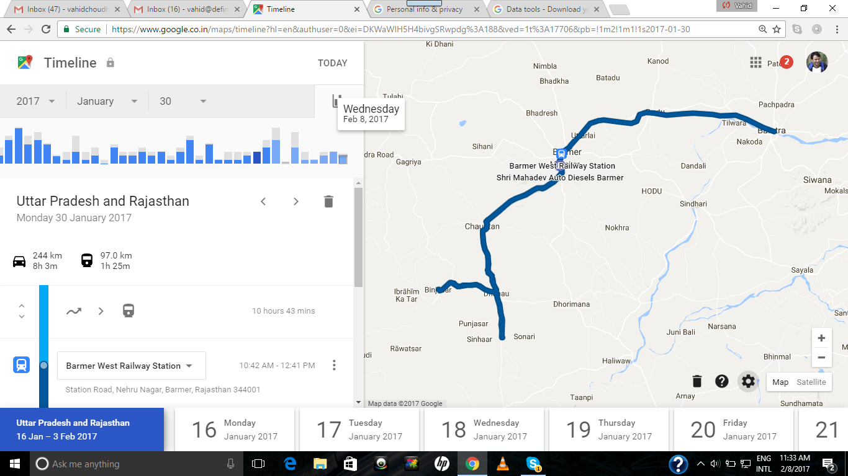
Overall observations & suggestions for Dhanau block
- Digital literacy in SSK is zero and there is no use of laptops & Desktops. So, SSK team should urgently distribute the systems to SoochnaPreneurs so that systems can be used and Oracle targets can be expedited.
- Team is focusing on social security schemes only which is somehow understood the demand is coming from the beneficiaries but we need to enforce special focus on all categories equally.
- SSK need to work on partnerships with multi stakeholders, government departments, SHGs, schools, Anganwadis and civil societies/organisations.
- Liaising & advocacy with government department and NGOs will give extra boost to the program at grassroots level.
- Open new SoochnaPreneur Kendra keeping in consideration the market potential, risk, challenges and threats.
- Need to complete Oracle target 500 digital literacy per centre latest by the end of February, 2017.
- SSKs including SP Kendra need to explore and engage more services into their basket.
- Need to adopt a multi services approach
Day-2 (January 31, 2017)
Visited places
- SSK Ranigaon
- SSK (SoochnaPreneur) Punro Ki Basti
- SSK (SoochnaPreneur) Shiv
- SSK Bayatu
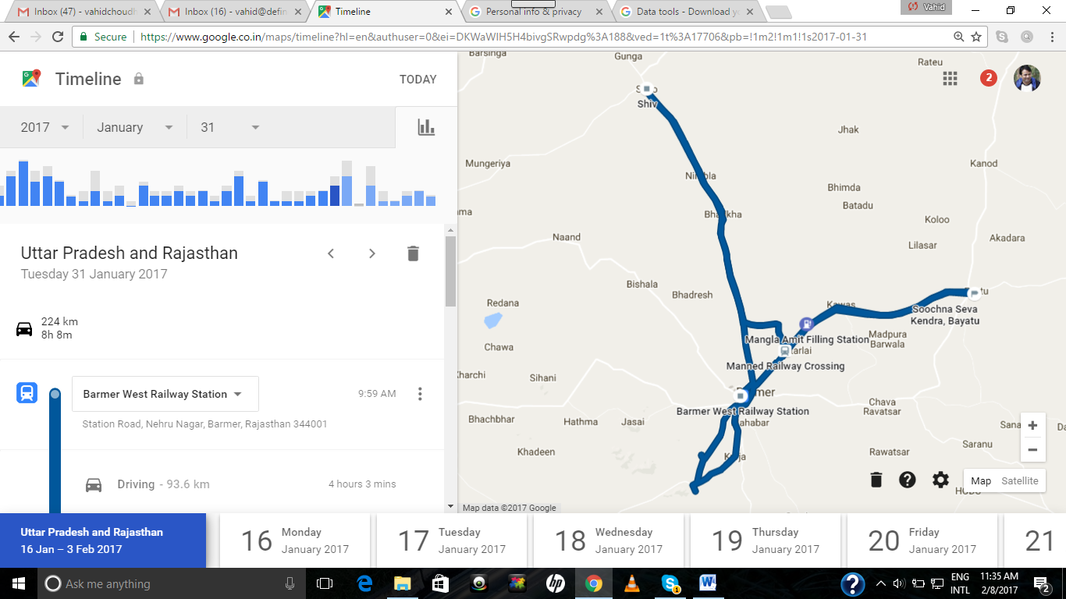

Overall observations & suggestions
- Digital literacy at these two SSKs is least and there is no use of laptops & Desktops. So, SSK team should urgently distribute the systems to SoochnaPreneurs so that systems can be used for providing mobile services.
- Team is focusing on social security schemes only which is somehow understood the demand is coming from the beneficiaries but we need to administer special focus on all categories equally.
- SSK need to work on partnerships with multi stakeholders, government departments, SHGs, schools, Anganwadis and civil societies/organisations.
- Liaising & advocacy with government department and NGOs will give extra boost to the program at grassroots level.
- Open new SoochnaPreneur Kendra keeping in consideration the market potential, risk, challenges and threats.
- SSKs including SP Kendra need to explore and engage more services into their basket.
- There is urgent need to give extra handholding support to Bayatu SSK in every aspect.
- Need to recruit SoochnaPreneur in Bayatu, Barmer and Shiv urgently
- Need to adopt a multi services approach
ACTION PLAN
S. No. | Task | Responsible person | Timeline
1 | Hiring of SoochnaPreneurs | Shishir Purohit | 28-Feb-17
2 | Opening of 10 SoochnaPreneur Kendra  1 in Bayatu, 1 in Kalyanpur, 3 in Siwana, 2 in Barmer, 2 in Dhanau & 1 in Shiv | Shishir Purohit/Block team | 28-Feb-17
3 | Online MIS of Soochna Seva, SoochnaPreneur & Oracle centers | Block team including SoochnaPreneurs | 15-Feb-17
4 | Registration by SoochnaPreneurs of 200 beneficiaries under various schemes | SoochnaPreneurs | 28-Feb-17
5 | Rs.2000/- revenue earning in a month | SoochnaPreneurs | 28-Feb-17
6 | Partnership with block/district administration, NGOs, Schools, Anganwadi, ASHA, ANM, SHGs, and concerned service providers | Block team including SoochnaPreneurs | 28-Feb-17
7 | Oracle target 500 digital literacy by each center | Shishir/Oracle Fellows | 28-Feb-17
8 | Equal work on each category and special focus on Health, Education, Livelihood and Social Security | Shishir Purohit/Block team | 28-Feb-17
9 | Equal distribution of laptops in SoochnaPreneur Kendra to increase digital literacy | Shishir/SoochnaPreneurs | 28-Feb-17
10 | Regular liaising and advocacy with district administration and service provider | SSK/SP/Oracle team | 28-Feb-17
11 | Expansion of service basket | SoochnaPreneurs | 28-Feb-17
12 | E-mitra IDs for SSK, SPs & Oracle center | Shishir Purohit | 28-Feb-17
13 | CSC registration ID for every Kendra | Shishir Purohit | 28-Feb-17
14 | Find out options for Banking correspondent for each SP | Shishir Purohit | 28-Feb-17
15 | Preparation for Prayag | Shishir Purohit | 20-Feb-17

Day-3 (February 01, 2017)
Visited places
- Siwana SSK
- Siwana SoochnaPreneur Kendra
- Ramaniya Oracle center
- Kalyanpur SSK
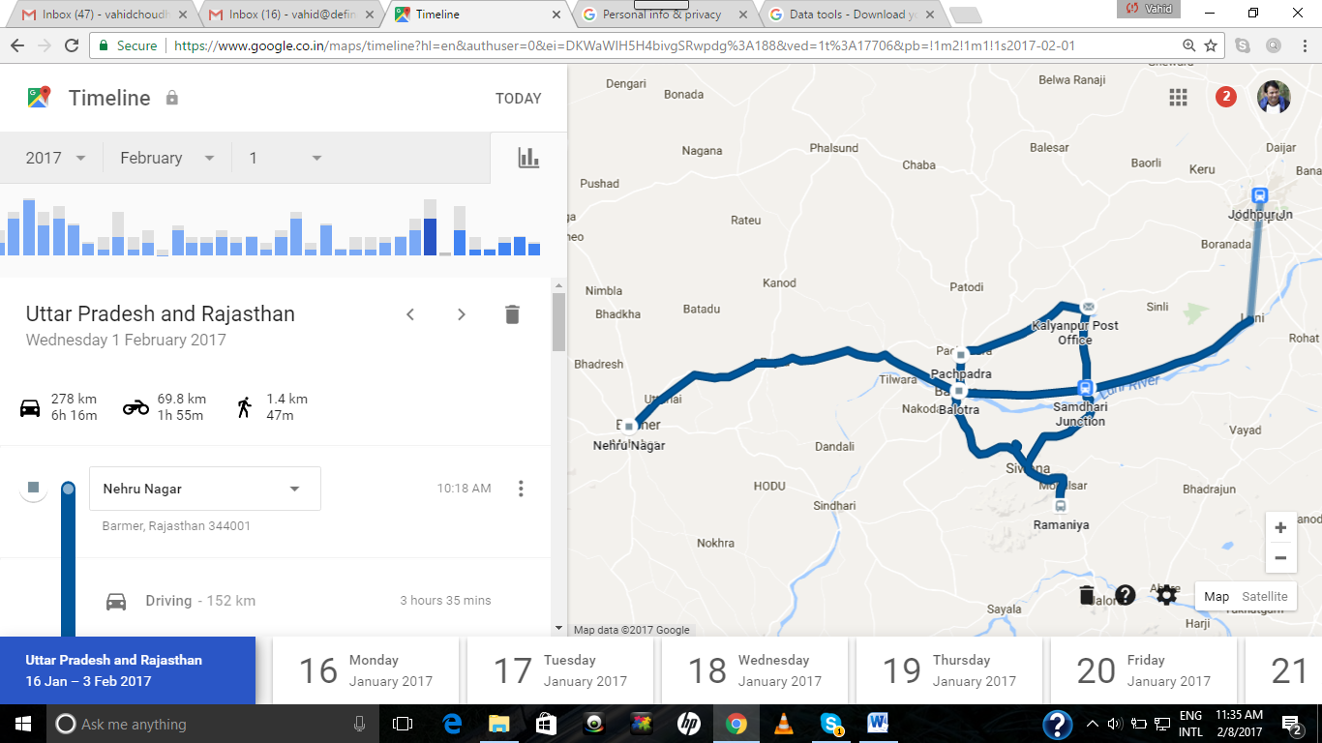
- Digital literacy at these two SSKs is least and there is no use of laptops & Desktops. So, SSK team should urgently distribute the systems to SoochnaPreneurs so that systems can be used for providing mobile services.
- Team is focusing on social security schemes only which is somehow understood the demand is coming from the beneficiaries but we need to administer special focus on all categories equally.
- SSK need to work on partnerships with multi stakeholders, government departments, SHGs, schools, Anganwadis and civil societies/organisations.
- Liaising & advocacy with government department and NGOs will give extra boost to the program at grassroots level.
- Open new SoochnaPreneur Kendra keeping in consideration the market potential, risk, challenges and threats.
- SSKs including SP Kendra need to explore and engage more services into their basket.
- There is urgent need to give extra handholding support to Siwana & Kalyanpur SSK in every aspect.
- Need to fill online MIS of Soochna Seva, SoochnaPreneur & Oracle
- Need to expedite the work in order to achieve the targets
- Need to recruit SoochnaPreneur in Siwana & Kalyanpur and Shiv urgently
- Need to adopt a multi services approach
Day-4 (Feb 2, 2017) Alwar SoochnaPreneur Centers
Visited places
- Raibka SSK (Soochnapreneur) in Laxmangarh Block of Alwar
- Nangal Khanjadi SSK (Soochnapreneur) in Laxmangarh Block of Alwar
- Jona Kheda Pahar, SSK (Soochnapreneur) in Kishangarh Block of Alwar

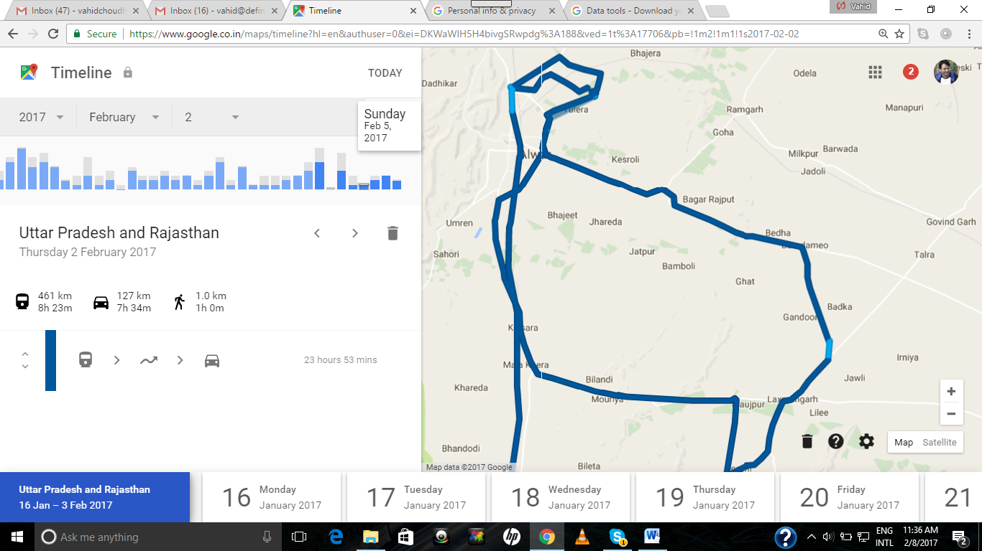
In Alwar, a total of 11 SoochnaPreneurs (out of 12) have been hired and these are associated with 6 Soochna Kendra. DEF is implementing SoochnaPreneur
These eleven SoochnaPreneur need constant handholding support on a daily basis. Considering the fact, Pankaj Sharma will support them and make a routine base plan. He should visit one SP center every day and stay over the night in a village. Also, should visit the market along with Soochnapreneur. It will be very useful if Pankaj, liaison with government administration at block and district level.
Tasks for Pankaj Sharma
- Regular visit to SoochnaPreneur center and stay over in night
- Field visits along with SoochnaPreneur to the villages in order to register the beneficiaries.
- Project visibility regularly
- Strong liaising & advocacy with Govt. administration at block, district and state level.
- Partnerships with local NGOs, SHGs, block administration, service providers etc.
- Increase services and scheme entitlements
- Filling up online MIS
- Collection of schemes and their application forms from block administration
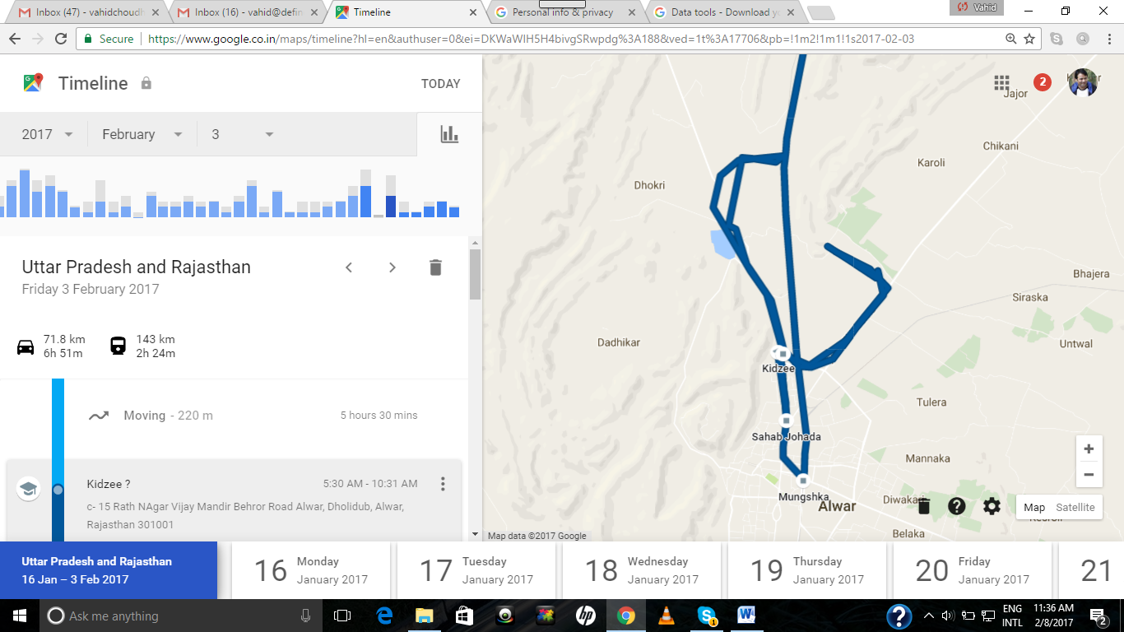

Note: A strong recommendation is a senior person should be deployed in Barmer to provide regular handholding support.

IMAGES
